1/1/22

Notice to Clients and Prospective Clients:
Under the law, health care providers need to give clients who don’t have insurance or who are not using insurance an estimate of the expected charges for medical services, including psychotherapy services.

You have the right to receive a Good Faith Estimate for the total expected cost of any non-emergency healthcare services, including psychotherapy services.

You can ask your health care provider, and any other provider you choose, for a Good Faith Estimate before you schedule a service, or at any time during treatment.

If you receive a bill that is at least $400 more than your Good Faith Estimate, you can dispute the bill. Make sure to save a copy or picture of your Good Faith Estimate.

For questions or more information about your right to a Good Faith Estimate, or how to dispute a bill, see your Estimate, or visit www.cms.gov/nosurprises.

Regards,

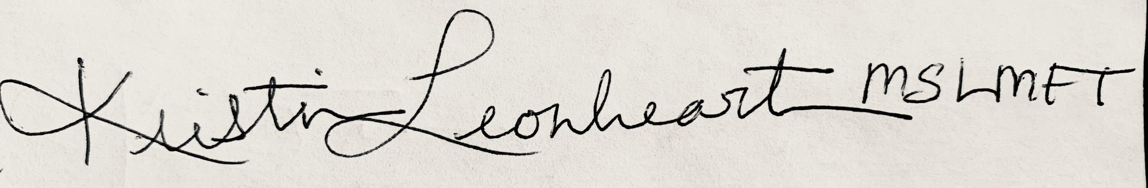

Kristin Leonheart, M. S., LMFT
Phone: (919) 537-9208
Email: kristinleonheart@gmail.com
Website: http://www.kristinleonheart.com
License #: 1613

